3.87: a) 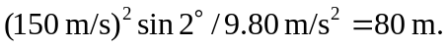
b) 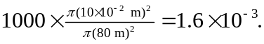
c) The slower rise will tend to reduce the time in the air and hence reduce the radius. The slower horizontal velocity will also reduce the radius. The lower speed would tend to increase the time of descent, hence increasing the radius. As the bullets fall, the friction effect is smaller than when they were rising, and the overall effect is to decrease the radius.

